Treasury Management Annual Report

Purpose of report

For decision.

Summary

Members are asked to note the LGA’s Treasury Management investment performance for the year to 31 December 2018.

Recommendation

The Members are invited to note the LGA’s annual Treasury Management performance for the year to 31 December 2018.

Action

As directed by the members.

Contact officer: Jonathan Gratte

Position: Strategic Finance Manager

Phone no: 0207 187 7309

Email: jonathan.gratte@local.gov.uk

Treasury Management Annual Report

Background

1. In accordance with recommended good practice, a report is provided to members each year on the LGA’s Treasury Management performance.
2. The LGA operates an “investment pool” whereby funds are invested collectively to share risk and take advantage of better interest rates available to larger investments, on behalf of the following organisations:
   1. The Local Government Association;
   2. The Improvement and Development Agency;
   3. Local Government Management Board Limited;
   4. LGA (Properties) Limited;
   5. LGA Commercial Services Limited;
   6. Public Sector Services Appointments;
   7. Centre for Public Scrutiny;
   8. Leadership Centre; and
   9. Local Partnerships.
3. The purpose of the approved Treasury Management Policy is to ensure that funds held by the LGA and its related bodies are, first and foremost, secure; second, that adequate liquidity is maintained so that sufficient funds are always available to meet current liabilities; and third, that the best return on investment is obtained subject to achievement of the first two objectives.
4. In March 2018, Leadership Board approved changes to the Treasury Management Policy in order to potentially increase investment yields within the objectives set out above, however delays in securing the external loan for the redevelopment of the LGA Group’s investment properties (£20 million from Westminster City Council) has meant that cash balances throughout 2017 have been lower than previously expected, such that there has been little opportunity to exploit the new investment policy.
5. Average cash balances over the coming 12 months are forecast at over £23 million for the LGA, IDeA and the two property companies. This is largely due to the injection of funds from the WCC loan, which is primarily being used to fund the investment in the Layden House development project. Additional pooled funds from Local Partnerships, the Centre for Public Scrutiny and the Leadership Centre bring projected combined average cash balances to between £30 million and £40 million.

Issues

Treasury Management Activity and Investment Performance

1. During the year we have made use of the opportunity to invest in a wider range of counterparties in the light of the wider opportunities provided by the approved 2018 Treasury Management policy. No investment limits per the policy were breached.
2. Since the last annual report was made to Members, the key objectives of security and liquidity have been fully achieved, with no losses, and money always available to meet commitments. Opportunities to optimise the yield within the policy has improved due to the interest rate rises in November 2017 and August 2018. However, during the year the delays in securing the Westminster loan meant that less funds were available for interest-bearing investment.
3. When the Leadership Board last received performance figures in February 2018, the LGA’s investment portfolio at December 2017 was at £22m, had a weighted average term duration for the year of 88 days and an average running yield of 0.32 per cent. This was lower than the rate for 3 month interbank lending deposits which was 0.44 per cent.
4. The chart below gives details, over the last 12 months, of investment performance against the 3-month bond yield benchmark rate. We previously benchmarked against the BoE Interbank lending rate but this information is no longer available. In summary, the average returns now yield 0.47 per cent which is almost exactly on par with the rate for 3 month bond yield average rate of 0.45 per cent.

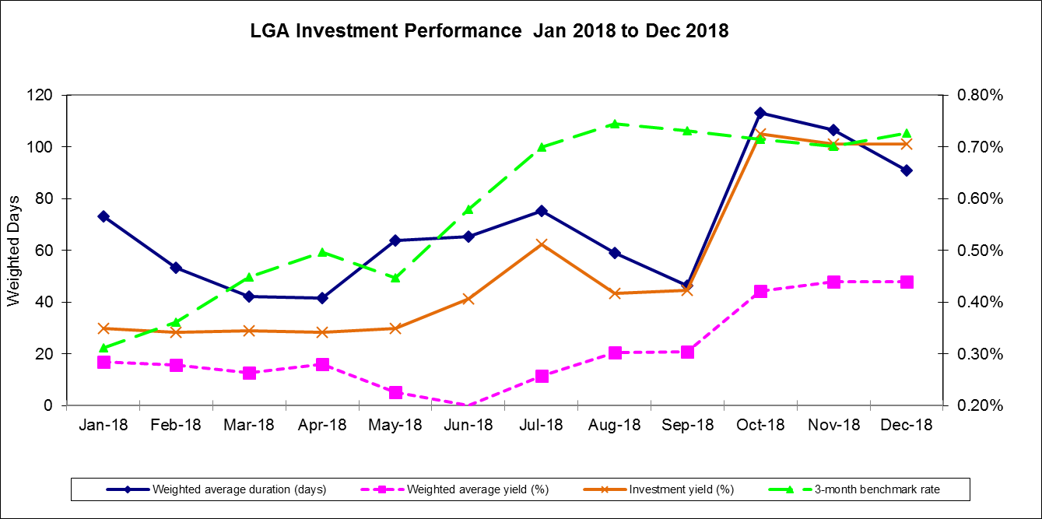

1. The current investment position as at 31 December 2018 is shown in the table below:



1. The above balances include £13 million investment funds from Local Partnerships; Public Sector Audit Appointments Ltd; Centre for Public Scrutiny; and Leadership Centre within the LGA Treasury Management pool.
2. The assumptions in the chart below are that, following the receipt of the Westminster loan in October 2018, subscriptions are substantially received in June 2019, with the phased expenditure on the Layden House refurbishment (per the latest development report) also factored in.

Implications for Wales

1. None.

Financial Implications

1. As above.

Next steps

1. Members are asked to note the LGA’s annual Treasury Management performance for the year to 31 December 2018.